Data Analysis using SQL on IMDB Movies Dataset

Summary
Explored the IMDB Movies dataset to analyze trends in movie production, genres, and revenue patterns. Cleaned the data by eliminating duplicates and filling missing values in key fields like genres. Identified the highest-rated movies, most common genres, and production trends over decades. Additionally, analyzed financial data to highlight top revenue contributors and cumulative earnings by country.

IMDB Movie Dataset: Link

- Remove duplicate records for unique movies.

To Identify any duplicate records

SELECT * FROM
(
SELECT NAMES, DATE_X, SCORE, GENRE, OVERVIEW, CREW, ORIG_TITLE, STATUS, ORIG_LANG, BUDGET_X, REVENUE, COUNTRY,
ROW_NUMBER() OVER(PARTITION BY NAMES, DATE_X, SCORE, GENRE, OVERVIEW, CREW, ORIG_TITLE, STATUS, ORIG_LANG, BUDGET_X, REVENUE, COUNTRY ORDER BY DATE_X ASC) AS DUPLICATE_IDENTIFICATION
FROM IMDB_MOVIES)
WHERE DUPLICATE_IDENTIFICATION > 1;

If found, any duplicate records then:
DELETE FROM
(

SELECT NAMES, DATE_X, SCORE, GENRE, OVERVIEW, CREW, ORIG_TITLE, STATUS, ORIG_LANG, BUDGET_X, REVENUE, COUNTRY,
ROW_NUMBER() OVER(PARTITION BY NAMES, DATE_X, SCORE, GENRE, OVERVIEW, CREW, ORIG_TITLE, STATUS, ORIG_LANG, BUDGET_X, REVENUE, COUNTRY ORDER BY DATE_X ASC) AS DUPLICATE_IDENTIFICATION
FROM IMDB_MOVIES)
WHERE DUPLICATE_IDENTIFICATION > 1;

Output:

- Handle NULL values in ratings and genres.

Identify the null values in Genre

SELECT *
FROM IMDB_MOVIES
WHERE GENRE IS NULL ;

Output:

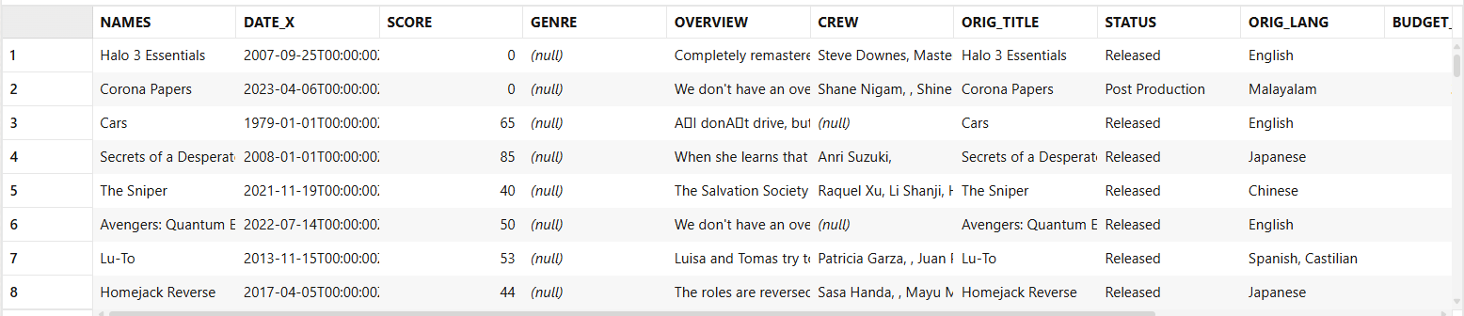

Update the null values in Genre with Unknown
UPDATE IMDB_MOVIES
SET GENRE = 'UNKNOWN'
WHERE GENRE IS NULL;

Output:

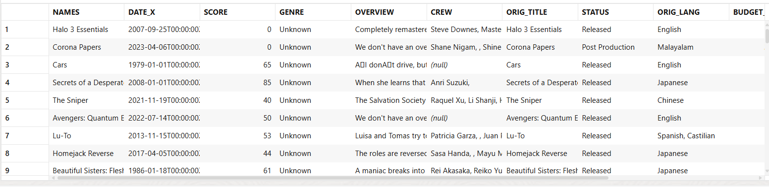

- Top-Revenue generated movies based on each country.

SELECT * FROM
(
SELECT NAMES, DATE_X, SCORE, GENRE, OVERVIEW, CREW, ORIG_TITLE, STATUS, ORIG_LANG, BUDGET_X, REVENUE, COUNTRY,
ROW_NUMBER() OVER (PARTITION BY COUNTRY ORDER BY BUDGET_X DESC) AS RANKING_BY_BUDGET_PER_COUNTRY
FROM IMDB_MOVIES)
WHERE RANKING_BY_BUDGET_PER_COUNTRY <=3
ORDER BY COUNTRY, RANKING_BY_BUDGET_PER_COUNTRY ASC;

Output:

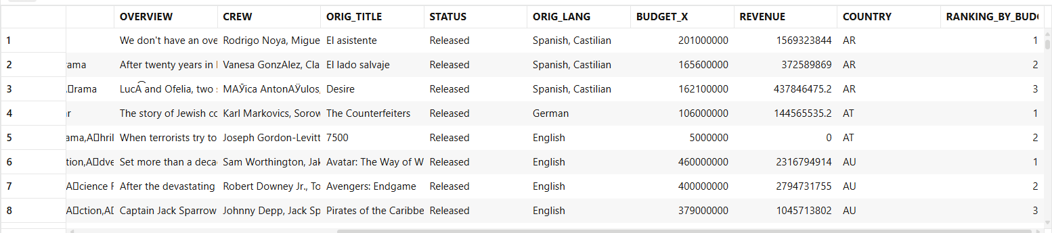

4. Analyze decade-wise trends in movie production.

SELECT
FLOOR(EXTRACT(YEAR FROM DATE_X) / 10) * 10 AS DECADE,
COUNT(*) AS MOVIECOUNT
FROM IMDB_MOVIES
GROUP BY FLOOR(EXTRACT(YEAR FROM DATE_X) / 10) * 10
ORDER BY MOVIECOUNT DESC;

Output:

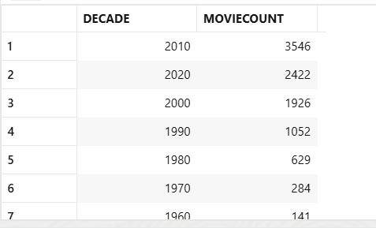

5. Rolling 5-Year Budget Analysis for Movie Trends.

SELECT
EXTRACT(YEAR FROM DATE_X) AS YEAR,
AVG(BUDGET_X) OVER (ORDER BY EXTRACT(YEAR FROM DATE_X) ROWS BETWEEN 4 PRECEDING AND CURRENT ROW) AS ROLLINGAVGBUDGET
FROM IMDB_MOVIES;

Output:

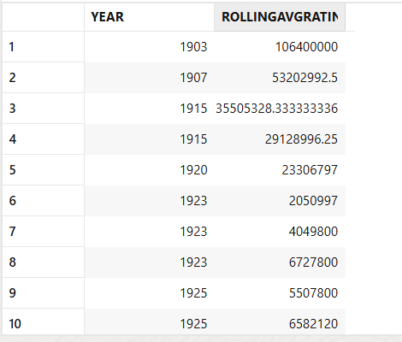

6. Most popular genres by frequency.

SELECT
GENRE,
COUNT(*) AS GENRECOUNT
FROM IMDB_MOVIES
GROUP BY GENRE
ORDER BY GENRECOUNT DESC;

Output:

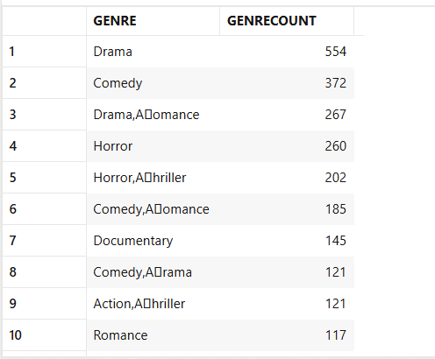

7. Top 10 movies by rating.

SELECT
NAMES,
SCORE
FROM IMDB_MOVIES
ORDER BY SCORE DESC
LIMIT 10;

Output:

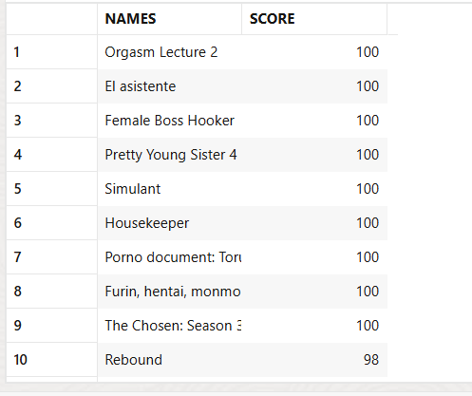

8. Cumulative Revenue for each country

SELECT
COUNTRY,
NAMES AS MOVIE_NAME,
REVENUE AS REVENUE,
SUM(REVENUE) OVER (PARTITION BY COUNTRY ORDER BY REVENUE ASC) AS CUMULATIVE_REVENUE
FROM
IMDB_MOVIES
ORDER BY
COUNTRY, REVENUE, CUMULATIVE_REVENUE DESC;

Output:

